BIG REVIEW – LAST QUIZ
1. Matter and Atoms
When you look up at the night sky, do you ever wonder where all the material that makes up the stars, Earth, the planets and you came from? And what is this material, anyway?
Turns out that the material that makes all of these things is essentially the same: particles of energy bound together in the form of atoms. These particles create what we call matter. All of the material in the universe is matter. The first matter is thought to have been formed 14 billion years ago during the Big Bang.
So, after stars were formed, all other atoms were able to emerge from two original atoms, Hydrogen and Helium. This was the beginning of matter as we know it.
Matter is the material that forms everything we know. All matter has mass, even gases. You can measure mass in grams. All matter also occupies space, or has volume. Volume is measured using litres or cubic metres.
Matter is made out of atoms. Atoms are small, and made out of three different particles: protons and neutrons in the centre, and electrons around.
Protons (+) are positively charged.
Electrons (-) are negatively charged.
Neutrons are not charged, and help keep the nucleus stable by stopping the protons from touching.
Electrons have much more energy than the protons and neutrons, which is why they have the ability to move around. Depending on the amount of energy matter has, it can change states. The more energy you add, the further apart the atoms become and the more movement between them.
States of Matter
Solid:
- Has a definite volume and definite shape
- Molecules are tightly packed
- Does not flow easily – particles cannot move/slide past one another

Liquid:
- Has a definite volume but no definite shape
- Lots of free space between molecules
- Flows easily – particles can move/slide past one another
- Takes the shape and volume of its container

Gas:
- Has no definite volume or definite shape
- Lots of free space between molecules
- Flows easily – particles can move/slide past one another
- Takes the shape and volume of its container

Plasma:
- Has no definite volume or definite shape
- Lots of free space between molecules
- Flows easily – particles can move/slide past one another
- Takes the shape and volume of its container
- Is electrically conductive

Plasma -- the state with the most energy, and the last to be discovered -- was actually the very first state of matter in the Universe. Only after plasma cooled down, we were able to see all the other states of matter forming.
Plasma has similar properties when comparing to gas, but it is also electrically conductive. Examples of plasma include stars, lightning, fluorescent lights and neon lights.
2. Elements, Molecules and Compounds

We are made of star stuff. But the particles that stars released to create the Universe are not all the same; some of them have more electrons and protons, and some of them have less. Hydrogen, for instance, has only one electron and one proton. In fact, there are over a hundred known types of atom, and more of them are discovered every few years.
Matter that is made up of only one kind of atom is an element.
An element is a pure substance that cannot be broken down into any other substance.
It is represented on the periodic table by a symbol.
Did you know that about 98% of our bodies is made out of only 6 elements? These are Oxygen, Hydrogen, Carbon, Nitrogen, Calcium and Phosphorous. These elements combine in different ways to make most of the ingredients that form our bodies.
Oxygen: 65%
Carbon: 18%
Hydrogen: 9.5%
Nitrogen:3.2%
Calcium: 1.5%
Phosphorous: 1%
Humans and Earth lifeforms in general are considered carbon-based. That means many of the larger molecules found in every living thing have a Carbon atom tying them together.
There are many different kinds of atoms, but in the beginning, the Universe had only two atoms: Helium and Hydrogen. Only after these atoms formed high temperature stars, other elements were formed in the plasma within; as stars collapsed and cooled, these elements were dispersed throughout the Universe.
We organize these elements on a chart we call the Periodic Table. This table organizes atoms by the number of protons they have. Usually, a stable atom will have the same number of electrons as protons.
Elements can combine to create different substances; the possibilities are nearly endless.
When two or more atoms bond together, they create a molecule.
Molecule:
- A pure substance formed when one or more elements have chemically combined through a chemical reaction to form a new substance.
- 2 or more atoms bonded together
- Represents the smallest particle in a chemical compound that can take place in a chemical reaction
- Has the same chemical reactions as that element or compound
- Some molecules consist of two atoms of the same element.
Ex.: O2
- Other molecules consist of two or more atoms of different elements.
Ex.: H2O
When a molecule is made of two or more different elements, we call that molecule a compound. So, H2O is a compound.
Compound:
- A pure substance formed when two or more elements have chemically combined through a chemical reaction to form a new substance.
- Represented by a formula, such as NaCl.

Unlike a compound, a mixture consists of two or more substances that can be separated, such as milk, toothpaste or cereal. In a mixture, there has been no chemical reaction, so no molecules recombined and no permanent alteration happened.

3. Classifying Matter
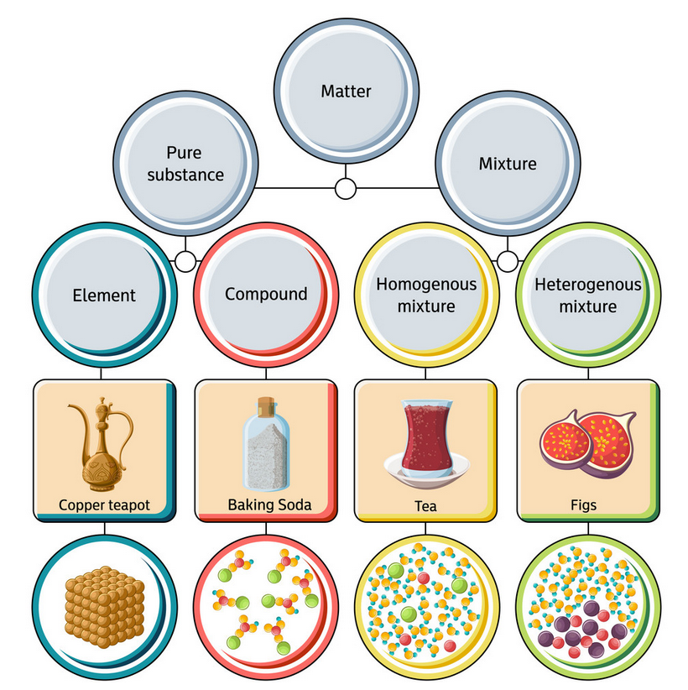
Elements, compounds, atoms and molecules are all pure substances. Mixtures can be solutions (homogeneous mixtures) like tea, toothpaste or orange juice, or heterogeneous mixtures, like trail mix, cereal or fruits with seeds.
The water we drink is far from pure; it actually contains more than just water molecules. It also contains natural minerals and salt. This makes tap water a homogeneous mixture. If you buy plastic bottled water, you are also drinking contaminants 97% of the time, as well as microscopic particles of plastic. The only water that is a pure substance is distilled water; it is made only of H2O molecules.
In British Columbia, we are lucky to have a relatively clean tap water, free of pollutants and (depending on the age of your pipes) free of heavy metals. This is not the same situation around the world, however. While we do take water for granted, the majority of the world sees it as a valuable resource, and many people have never had a glass of water that tastes as refreshing as our water in British Columbia.
Drinking water is not only a valuable resource, it is also rare and finite. It is important to try and keep it as clean as possible.
Properties of pure substances
One thing that all pure substances have in common is, they retain their properties, no matter where they come from or where on Earth they were found. A grain of salt in Canada is equal in molecular structure to a grain of salt in Russia; a drop of distilled water in Brazil is the same as a drop of distilled water in Jamaica. These similarities are called the substance's properties. They can be physical properties or chemical properties.
Physical properties: properties that can be measured, and that define each pure substance.
Ductility - How easily and how far a substance can be stretched before breaking. This enables a material to be drawn out into thin wires.
Malleability - How easily a substance can be formed into other shapes by applying pressure on it. Gold is the most malleable substance.
Solubility - How much of a substance can be dissolved in a particular solvent.
Mass - How much matter something contains.
Freezing point, Melting point and Boiling point
Weight - How much gravity pulls on an object.
Colour - What colour a substance has in its natural state.
Lustre - How shiny something is.
Density - A measure of how heavy something is in relation to its size. For instance, a 10" cube filled with sand will be more dense than a 10" cube filled with plastic beads. The sand is therefore more dense. You calculate density by dividing the mass of a substance by its volume.
Chemical Properties: Unlike physical properties, they can only be observed when matter goes through a chemical change. Examples of chemical properties are as follows:
Flammability - How easily something catches on fire.
Oxidation - How a metal reacts with the oxygen in the air, causing it to rust.
Heat of combustion - How much heat or energy is released when something burns all the way to ashes.
Crystalline versus Amorphous Structures
Having a crystalline structure is also a physical property of some solids; this refers to how the atoms and molecules arrange themselves. Crystalline structures are arranged in such an orderly way that when they break, they usually break in a line, much like a diamond can be chipped in slices. The structure in the diamond is also what makes it the hardest natural substance on Earth. Salt crystals also are organized the same way, as well as quartz and other crystals.
Other solids, however, have an amorphous structure. These solids have molecules that are arranged randomly. They include foams, gels, mayonnaise, but also substances like glass, silicone and coal. When you break them, they do not break on a straight line; they also have different points of weakness.

4. Physical and Chemical Changes

Matter can change. Some changes to matter are called physical changes. During a physical change, the substance remains the same. For instance, you can change paper by cutting it, but it is still paper. When you freeze water, the molecules are still water; nothing changed. Every phase change -- from solid to liquid, from liquid to gas, and vice-versa - is a physical change.
A chemical change, on the other hand, occur when atoms rearrange and come together to form one or more new substances with new properties. During a chemical change, there is also a change in energy, such as the production of heat or light.
Nature also faces many chemical changes. And not just from forest fires... Living things, for instance, have a life cycle that usually ends in death and decomposition. The thing to keep in mind is, even though the substances' atoms recombine and change, the atoms themselves are the same. The majority of the atoms in the Earth have been there for millions of years (with exception of some meteors). A Carbon atom inside you today may be inside a tree in a hundred years; the Hydrogen in the water you drink today was around since before the time of the dinosaurs, and was probably inside several different types of animals before.
Many people since the beginning of humanity, including First Peoples, observed chemical changes in their environment. Through observations and experience, they learned how they could use chemical changes in their lives.
They saw, for instance, how the skin of an animal changed when left under the Sun, and slowly developed a tanning process involving scraping, stretching and smoking the hide, to make it last a long time and become pliable and resistant to rot and wear.
In our sheltered modern lives, so detached from nature, we have somewhat lost the ability to observe changes around us and understand what they mean. This has proven to be a very serious issue, one that may become fatal for us as a species. Our disconnect to nature and our inability to see changes and understand their significance has caused the climate crisis, the water crisis and all that we are facing around the world.
Chemical changes are happening inside our bodies all of the time; when we digest food, when we breathe, and even inside the cells, when the oxygen produces energy for us to live.
Some chemical changes can be harmful to our bodies. On our teeth, for instance, the bacteria that live in our mouths feeds on pieces of food and eliminates acids, which dissolves the tooth enamel. Cavities are a result of chemical changes. Tanning is another chemical change created as your body tries to make a pigment to protect you from the Sun's harmful rays.
The final takeaway of this unit is, the matter in this Earth is fixed. Every atom that you see today has always been there in one form or another, combined with other atoms to form different molecules, in an infinite ballet of possibilities.
This has implications for how we use this matter. For instance, if we misuse or pollute drinking water, then those molecules of H2O will be locked in until they evaporate; this often takes longer if the molecules are stuck with pollution or wasted.
What we do with matter affects how long it will be before we can use it again. How might we change how we use materials to become a more sustainable planet? Consider how a more Earth-conscious existence might benefit future generations.

