Matter and Atoms

When you look up at the night sky, do you ever wonder where all the material that makes up the stars, Earth, the planets and you came from?
And what is this material, anyway?
Turns out that the material that makes all of these things is essentially the same: _______________________ bound together in the form of ___________. These particles create what we call ______________.

All of the material in the universe is matter. The first matter is thought to have been formed 14 billion years ago during ______________________.

After stars were formed, all other atoms were able to emerge from two original atoms, ______________________________. This was the beginning of matter as we know it.
________________ is the material that forms everything we know. All matter has mass, even ________________. You can measure mass in _____________. All matter also occupies space or has ______________. Volume is measured using _______________________________.
Matter is made out of __________. __________ are small, and made out of three different particles: ___________________________ in the centre, and _____________ around.
____________(+) are positively charged.
____________ (-) are negatively charged.
_____________ are not charged, and help keep the nucleus stable by stopping the ____________ from touching.
_____________ have much more energy than the protons and neutrons, which is why they have the ability to ___________________.

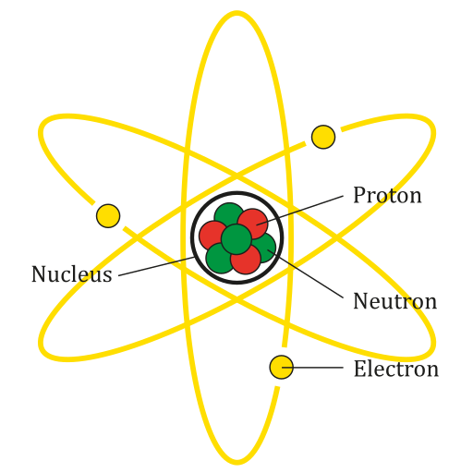

Depending on the amount of _____________ matter has, it can change _______________. The more energy you add, the ________________ the atoms become and the more __________________ between them.
Let's look at the states of matter that we know.
Solid:
- Has a definite _______________ and _________________
- Molecules are _______________________
- Does not _________________

Liquid:
- Has a definite ________________ but not a definite________________
- ____________ easily
- Lots of __________________ between particles
- Takes the _____________ and _________________ of its container
Gas:
- Has no definite ___________ or __________________
- Lots of __________________ between particles
- ______________ easily
- Takes the _____________ and _________________ of its container
Plasma -- the state with the _________________, and the last to be discovered -- was actually the _______________ state of matter in the Universe. Only after plasma ____________________, we were able to see all the other states of matter forming.
Plasma has similar properties when comparing to gas, but it is also ________________________. Examples of plasma include stars, lightning, fluorescent lights and neon lights.

