Group 1. John Dalton

John Dalton (1766–1844) is credited with developing a theory that was a new way of describing matter. He was a British schoolteacher and a scholar. His interest in the gases that make up Earth’s atmosphere led him to investigate the composition of a number of substances, such as carbon dioxide, water, and nitrogen oxide. In explaining some of his experimental results, he suggested that the particles that make up matter are like small, hard spheres that are different for different elements. He defined an atom as the smallest particle of an element. This is the basis for what is now known as Dalton’s atomic theory.

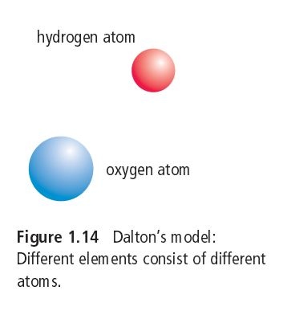
Dalton’s Atomic Theory:

• All matter is made of small particles called atoms.
• Atoms cannot be created, destroyed, or divided into smaller particles.
• All atoms of the same element are identical in mass and size, but they are different in mass and size from the atoms of other elements.
• Compounds are created when atoms of different elements link together in definite proportions.

According to Dalton’s theory, the atoms that make up gold are different from the atoms that make up lead, and atoms cannot be created or destroyed. You can use these points to explain why the alchemists were unable to change lead into gold.

Group 2. J. J. Thomson

Joseph John Thomson (1856–1940) was a British physicist who studied electric currents in gas discharge tubes, which are related to today’s fluorescent lights. He determined in 1897 that the currents were streams of negatively charged particles, later called electrons. He found that all substances used in his discharge tubes produced these particles. From the results of his experiments, he reasoned that all atoms must therefore contain such particles. In other words, he was hypothesizing that atoms are made up of much smaller particles. This was a startling proposal, since most scientists at the time thought that atoms were indivisible.

Thomson proposed a “raisin bun” model of the atom. His model pictured a positively charged ball like a bun with negatively charged particles embedded in it like raisins. His model was short-lived, however. Experiments by his student Ernest Rutherford soon pointed to a more accurate picture of the particles of an atom.

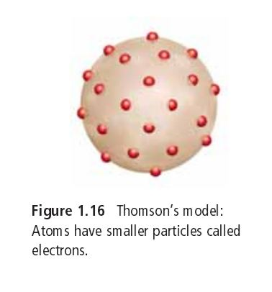

Group 3. Ernest Rutherford

Ernest Rutherford (1871–1937) was a scientist from New Zealand who worked for a while at McGill University in Montreal. In 1909 he designed an experiment to probe inside atoms. He exposed a very thin sheet of gold to a stream of high speed, heavy particles that had a positive charge, called alpha particles. The alpha particles were like tiny bullets. Rutherford put a detector screen around the gold foil to find out what would happen to alpha particles when they made contact with the gold atoms. An alpha particle became visible whenever it struck the screen. See the set-up for this experiment:

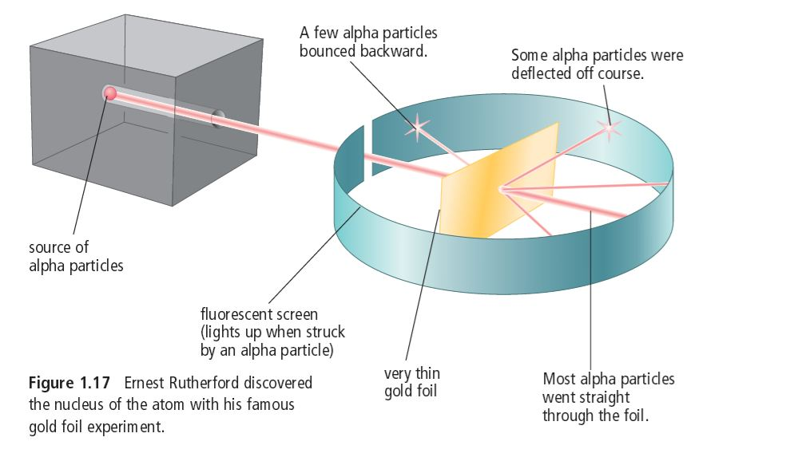

Rutherford’s results indicated that most of the alpha particles went right through the gold atoms without being affected. He had expected this, because he knew there must be relatively large space within atoms. However, he was astonished to see that a few alpha particles rebounded from the foil much as a ball rebounds from a solid wall. Rutherford had discovered the nucleus—the tiny, dense, positively charged centre of the atom. This was a tremendously important discovery. Rutherford had allowed us to peer inside the nucleus for the first time. A decade later, he also established that there must be at least two kinds of particles inside the nucleus of an atom. One particle, later called a proton, had a positive electric charge, and the other particle, called a neutron, had no electric charge.

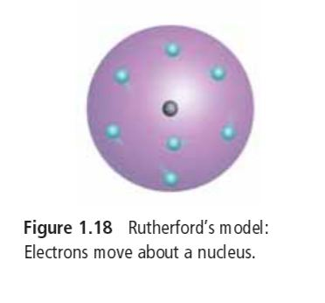

Group 4. Niels Bohr

Niels Bohr (1885–1962), a Danish physicist working under Rutherford, studied the regions surrounding the nucleus, which were now known to contain negatively charged electrons. Bohr studied the results of experiments on the light released by gaseous samples of atoms, such as those of hydrogen. In the experiments, the gases had been made to glow by passing an electric current through them. He proposed that electrons surround the nucleus in specific energy “levels” or “shells.” This meant that each electron has a particular amount of energy.

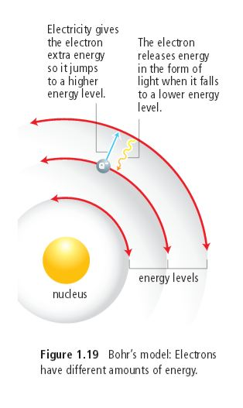
If you have ever seen a neon light, you have seen the effect of electrons jumping from one energy level to another. When electricity is added to the neon gas, the electrons in the neon atoms gain extra energy. They jump from low to high energy levels. When the electrons drop to lower energy levels, they release energy in the form of visible light. This light is evidence that the electrons exist in specific energy levels and can jump back and forth between them.

Group 5. Inside the Atom

An atom is the smallest particle of an element that retains the properties of the element. All atoms are made up of three kinds of smaller particles called subatomic particles: protons, neutrons, and electrons. Each has its own set of properties.

Mass
Protons and neutrons have much more mass than electrons. This means that when you lift up a large rock, it is the protons and neutrons in the rock that weigh it down. While protons and neutrons have about the same mass as each other, they have about 1800 times more mass than an electron.

Electric charge
Electric charge comes in two types: positive and negative. Protons have a positive charge, and electrons have a negative charge. Neutrons have no charge, and help keep the nucleus stable. Because negative and positive charges attract each other, protons (positive) and electrons (negative) are attracted together.

All atoms have an equal number of protons and electrons. This means that the charges add up to zero, making the atom uncharged or neutral.

The nucleus
The nucleus is a tiny region at the centre of the atom. Because of its protons, it has a positive charge. All atoms also have neutrons in the centre, and these neutrons help so that the protons don’t touch; the only exception is Hydrogen, which has no neutrons, since it has only one proton in its nucleus.

Since neutrons have no charge, the nucleus of a Nitrogen atom, with seven protons, has a charge of 7. A nucleus with 92 protons (as in uranium) has a charge of 92.

• Protons and neutrons are held in the nucleus and cannot normally enter or leave it.

Electrons
Electrons occupy special regions called energy levels, or shells, which surround the nucleus.

• The region that electrons occupy accounts for well over 99.99 percent of the volume of an atom. If a nucleus were the size of a hockey puck sitting at centre ice, the whole atom would include the entire ice sheet, the spectator seats, the building, and the parking lot surrounding it.

• Each electron occupies one whole energy level at a time. An electron is not like a fast-moving particle racing around the nucleus. It is more like a spread-out negative charge that exists in the whole region all at once.

Ignore your number, and collect information about the remaining groups.

1.

2.

3.

4.

5.

