Determining the Age of Fossils
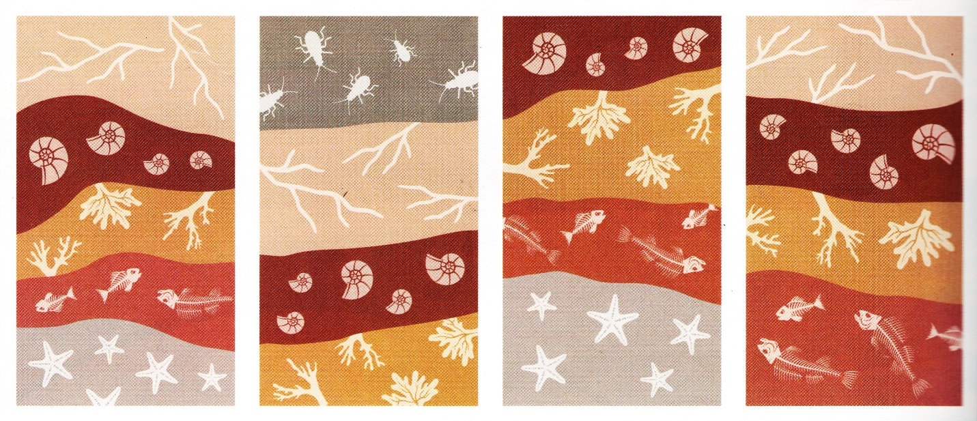
You are a group of paleontologists. You have found four samples of sedimentary rock. They show different layers and depths, indicating different ages for the fossil samples. Look for patterns in the layers of sedimentary rock. Note the location of the fossils found in the samples. Use the patterns and your understanding of how fossils are formed to match the samples.
Make a drawing of the matched-up samples below. Put the oldest layer at the bottom and the youngest layer at the top.

Which fossils are the oldest? Which are the youngest? How do you know?
Compare your findings with other groups.

