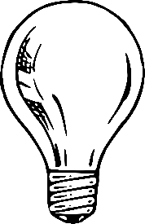
Quiz – Electricity 1 Student: ______ANSWER KEY________

- Jane is walking down a carpet corridor and shuffling to the beat of Imagine Dragons. What is happening to the atoms on her feet? Circle a letter below.

- They are losing electrons, making Jane negatively charged.
- They are losing protons, making Jane positively charged.
- They are losing electrons, making Jane positively charged.
- They are getting agitated by the music.

- When Jane touches a doorknob after dancing on the carpet, she gets a shock. This is caused by… (circle a letter below)

- Fantastic electricity
- Static electricity
- Current electricity
- Spastic electricity
- Sparkle electricity

- During a lighting strike, what is happening to the electrons on the Earth?

They are going up, forming a lighting bolt as they move towards the clouds.

- Haydn wants to make an experiment using electricity. She needs to use a material that is a good conductor. Which ones could she use from the list below? Circle three.

Gold Glass Nickel Plastic Aluminum Rubber Copper Salt water

- Why do you think a circuit has to be closed in order for a lightbulb to work?
Because the path for the electrons must not be broken. They only move because they are attracted to the positive side.

- Kolton was working with parallel circuits. He removed lightbulb #2 from the circuit below. What do you think happened to the other lightbulbs?
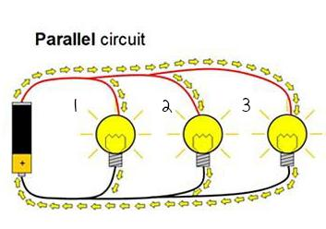
They stay on/ they get brighter

- He then built a series circuit and removed lightbulb #2. What do you think happened to the other lightbulbs?
They will turn off.
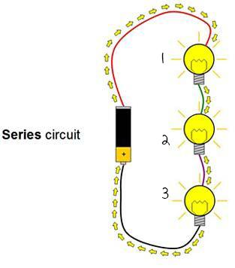

- Mason wanted to build a miniature house with working lights. He wanted them to be efficient, but also wanted all the lights to work, even if one of them failed. He watched Kolton’s work, and figured he would use… (pick a letter below)

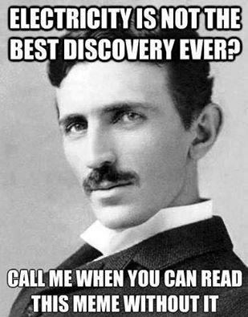
- Only series circuits
- Only parallel circuits
- A mixture of series and parallel circuits
- One battery and one lightbulb per light

- Why can’t we ever lose neutrons or protons?
Because they are in the centre of the atom. They are stuck very tight together and there is no way to lose them without breaking the atom, while the electrons come and go.
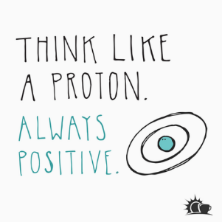

- Since we are made of mostly water, and a water molecule is made of two atoms of Hydrogen to one atom of Oxygen, what would the majority of our atoms be?

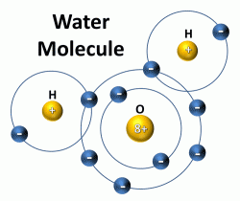

- Why is the wire for charging your phone covered in a rubber coating?

Cause otherwise we would get an electric shock.

- If an object gains electrons, what is the charge in the object now?

Negative.

- A battery has two poles: one negative and one positive. When the circuit is closed, how do the electrons travel? Draw the direction for the flow of electrons on the battery below by adding arrows to the drawing below.

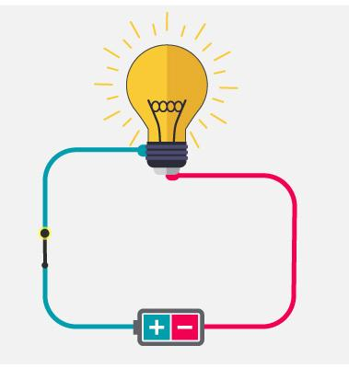

- Why are conductors so good at moving electricity?

- Because they are made of metal.
- Because their atoms have lots of electrons on outer layers.
- Because the electrons on their outer layers are very loosely bound.
- Because they are naturally electrified.

- When he turned 55, Evan got a hold of a powerful electron microscope and was able to count gold electrons. He saw that one previously neutral piece of gold had lost 35 electrons, then gained 15, then lost 5, then finally gained 25. The object now is…
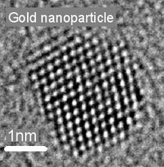
- Confused
- Negative
- Neutral
- Positive

- Makenna was invited to visit BC Hydro in Vancouver. She was very excited when she heard that they gave her a special pass to go near the biggest turbines and see how they work. What kind of shoes do you think they offered her?
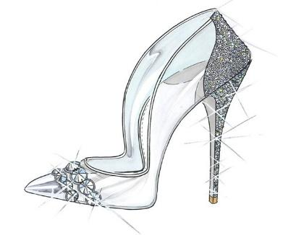
- Rugged looking rubber boots
- Dainty glass slippers
- Flip flops
- Loafers

Why do you think that is?

Because rubber is a good insulator.

- How does a battery work? Give your best answer below.

It works through a chemical reaction, creating electrons on one side while at the same time attracting electrons on the other side. Through oxidation and reduction.

- Complete the sentences below with the words on the square.

Ion Current Reduction Conductor Positive

Negative Insulator Oxidation Power Source Loads

- An atom who has lost or gained electrons is called an ___ION_____. They can be __POSITIVE__ or ___NEGATIVE__.
- An example of a good ____POWER SOURCE____ is a battery.
- Materials that can carry electricity easily are called _CONDUCTORS_.
- Rubber is a good example of an _INSULATOR__.
- _CURRENT_ electricity, unlike static electricity, is used by humans to power their homes.
- A battery works using two processes: _OXIDATION_ and _REDUCTION_.
- In a circuit, a lightbulb or an appliance are examples of _LOADS_____.

- What are magnets made of?
Metals; iron is the most common, but it could also be nickel, cobalt or some metal mixtures.

- Why is the Earth like a giant magnet?

Because it has a ball of iron in the centre, creating a magnetic field.
Because it attracts other metals.
Because it has a magnetic field.

- Around the magnet, where is the magnetic field at its strongest? Why do you think that is?

In the centre.
Near the poles.
The closest you are, the strongest the pull will be.

- What is the inner core of the Earth made of, and why is it solid?

It is made of iron, and it is solid because of the gravitational force.

- What is Solar Wind, and how is the Earth protected from it?
** Answer using the words “charged particles,” “shield,” “Aurora Borealis”

Solar wind is a cloud of charged particles that comes from the Sun towards the Earth. Thankfully, the Earth has a magnetic shield that protects us, dissipating the Solar Wind and generating the Aurora Borealis, or Northern Lights.
- Why is an electromagnet better than a regular magnet?

- Magnets are stronger than electromagnets.
- An electromagnet cannot be turned off.
- They are pretty much the same.
- The electromagnet is better because it can be turned on and off.

- How are magnetism and electricity connected?
One generates the other.
Electrons flowing generate magnetic forces.
Spinning magnets generate electricity.

- Liam got a compass for his birthday and kept following the red arrow no matter where it pointed. He ended up getting lost in the woods. Explain to Liam how a compass works so this doesn’t happen again.

A compass always points towards North, so you need to know where your house is if you are going to use a compass. Just following the arrow will just take you towards the North.

- In a car, when one headlight breaks, the others stay on. How do you think the headlights circuit is arranged?

- In series
- In conjunction
- In the right place
- In parallel

- Bonus: Tell me three beenefits of shifting towards renewable energy sources.

- The sources will never end, so we will always have that kind of energy
- It is better for the environment because it is cleaner
and expels less greenhouse gas
- It is cheaper after installation, and you can actually
make money out of renewable sources
- Improves public health
- Makes it possible for an individual to generate
their own energy at home
- Leads to job creation and usually a more
technologically advanced society

