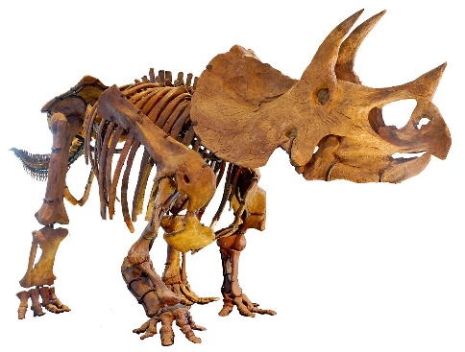
Fossils Summary – Student: ______________

Fossils are the evidence of life from the ________________. Without fossils, we would not know as much about ______________ as we do today! Fossils tell us what kinds of____________ and ______________ existed on Earth a long time ago, but also how they lived, what they ate and what their _________________looked like. A scientist that studies fossils is called a ___________________. As new fossils are found, we understand more about ___________________ and how we evolved.
Animal fossils give us a lot of clues about an animal's environment. It is hard to know what a dinosaur looked like; we have to _____________ it with animals we have nowadays to understand how prehistoric animals were built.
Fossils are formed from an _____________ organism or from __________ of an organism, such as a ____________________. Fossils can also be formed by _________________, __________ and ___________.
The best-preserved fossils happen when the _______________ somehow isolated the organism from __________. As more and more layers of ______________ and earth get deposited on top of the ______________, all the __________ is squeezed out of it and _____________ from the soil replace the _______________________ found in the organism, turning it into ____________. This process is called __________________.
One of the most important fossil ______________ in the world can be found right here in B.C.
It is called the ___________________, located close to the Alberta border in the Yoho National Park. These fossils are from the ___________ period, over ________ million years ago. These deposits are important because they show the imprints of the ______________ of the animals, in effect producing a ______________ of what the animal looked like.
One of these animals found in the shale was the __________________, a two-meter-long monster possessing primitive __________. The findings enabled paleontologists to come up with the depiction we know today.
The fossils enabled us to understand the life-expanding period known as the _______________________ and how all the _______________ fit together in harmony. It turns out every species had their place in the _________________, just as they do today.
There were the ______________, the ____________, the _____________, the ______________ and the ______________. Each one of them had their own job to maintain equilibrium in their environment.
How did these fossils become so well preserved? It turns out a _______________ happened a long time ago, isolating them from ___________ and ______________ that would have ________________ the organisms. This happened fast; the animals barely saw it coming. Many fossils are formed this way.
These Cambrian animals actually lived far away, near the ____________; after millions of years, __________________ movements displaced the now-petrified __________, pushing them up and eventually _____________ them here in B.C.
Not all fossils are found in sedimentary rocks. Sometimes, _________ organisms get trapped in ____________________, just like the movie Jurassic Park. When the resin hardens and turns to ___________, the organism becomes a ______________.
Some fossils can also be found in ___________. Technically speaking, they have not truly fossilized; they have just become trapped in ice, and so all the ______________________ could not have been replaced by ______________, which is why many of the original mammoths found frozen in ice have unfortunately __________________ rather quickly. The baby mammoth below is around 37 thousand years old. A well-known mammoth specimen was preserved very well because it was engulfed in ____________ and ______________ from the inside out -- fun fact!
After something dies, it is usually ___________ by another organism, or rots away. Very very few organisms become _______________, as the conditions have to be perfect. Three conditions must be met for an organism to become a fossil.
1. It must be ____________________________ that prevent other organisms from eating it
2. Its decomposition has been ______________________ because there is no ____________ or the temperature is very __________
3. The material that ______________ the organism has turned to __________ and hasn't moved for thousands or millions of years
The best remains have died near a river bed, or live in the water near the ocean floor.
When the sediment accumulates over time, it is deposited in ____________. These _____________ are clues about the _________ of the fossils. Just like when you make a cake, the bottom layer gets placed first, ___________ fossil layers are usually found below ____________ fossil layers. This helps paleontologists figure out the order in which _____________ took place.
Knowing which layer comes first helps us understand the _________________ of fossils; it does not tell us _____________ they are in years, but it helps us know how old they are in _________________ to each other. Fortunately, there is another way to find out the actual age of a rock or fossil. Many rocks contain tiny amounts of __________________________ elements that change over time. People use specialized instruments to take detailed measurements of these changes, which gives them the _____________________ of a fossil. One of the most popular elements is ____________. You can measure the age of some fossils using _____________________.
So, _____________________ is a more _______________ way to measure how old a fossil is.
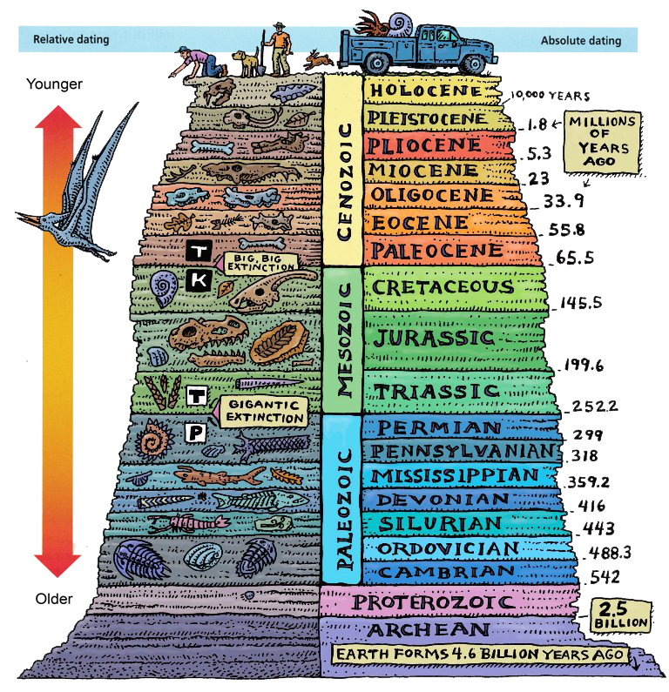
Fossils help us understand how life on Earth has changed over millions of years. They provide ______________ of the earliest organisms on Earth. The oldest fossils that have been found are from the ____________________, and are over _____________ years old. Looking at fossils helps us understand how their environment might have been like. The fossil below was called "Tiktaalik", which means "_____________________________". Why do you think it got this name? What evidence would you look for to confirm this prediction?
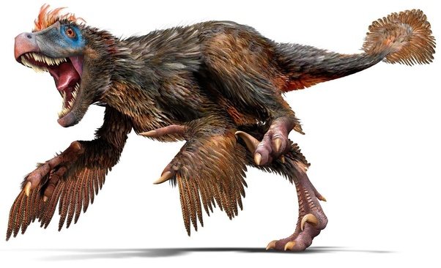
Besides helping us understand organisms and environment from a long time ago, fossils also provide evidence of ___________________ to species over time.
In 2017, a new species of ________________ dinosaur was found in Alberta. Due to a lack of originality, they called it the "__________________." Finding a fossil is easy, but depicting it in an illustration has proven to be very hard. Knowing what you know regarding current birds (the closest we have to dinosaurs), do you think the Albertavenator is more likely to have looked like the image on the left or the one on the right?
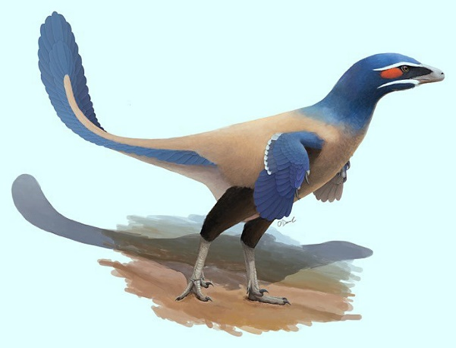
Hint: One of these sells tickets!
Based on _______________, Paleontologists have organized the history of life on Earth into a ____________________. This is known as the ________________________________. It represents the ____________ and ____________ that took place in Earth's past, and shows how these events are _____________.
The Geologic Time Scale is divided into _________ major time periods called ________, each subdivided into smaller chunks of __________.
Fossils provide evidence of species becoming more _____________, _____________ and _____________ over time. They also provide evidence that most of the species that were ever in the Earth are now ______________, or gone forever. Some extinctions happened _____________ while others happened _______________. There have been ________ mass extinctions so far, but the most well-known one was caused by a ________________ and decimated the large (_____________________) dinosaurs as well as many other species. After that time, there are no more fossils of those species.
The Geologic Time Scale below shows the five major extinction events. Note the ________________ increasing and the extinction events marked by the quick ________________ of fossils.
