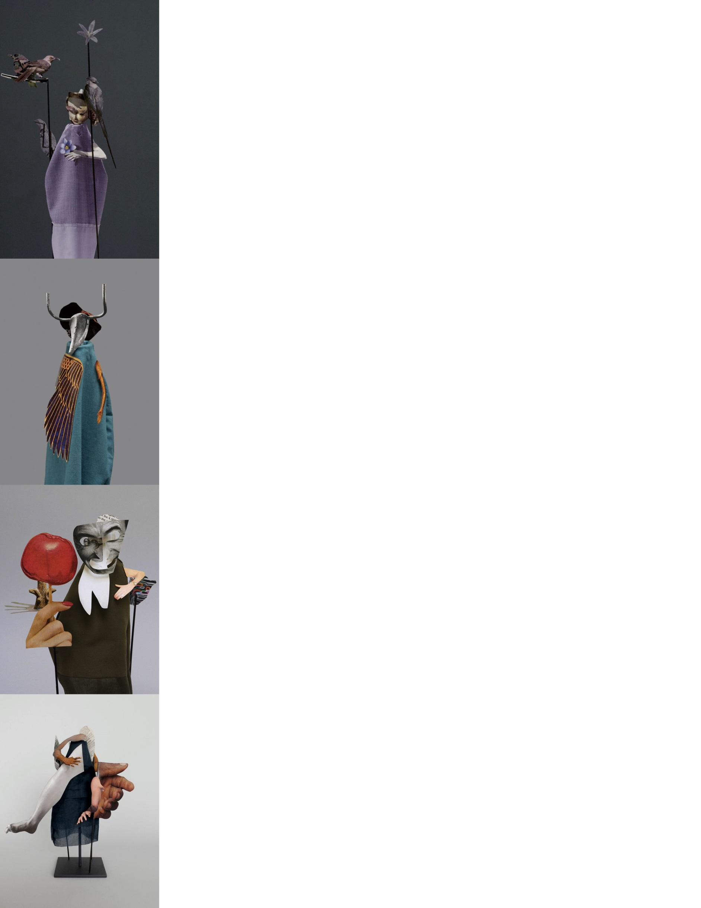
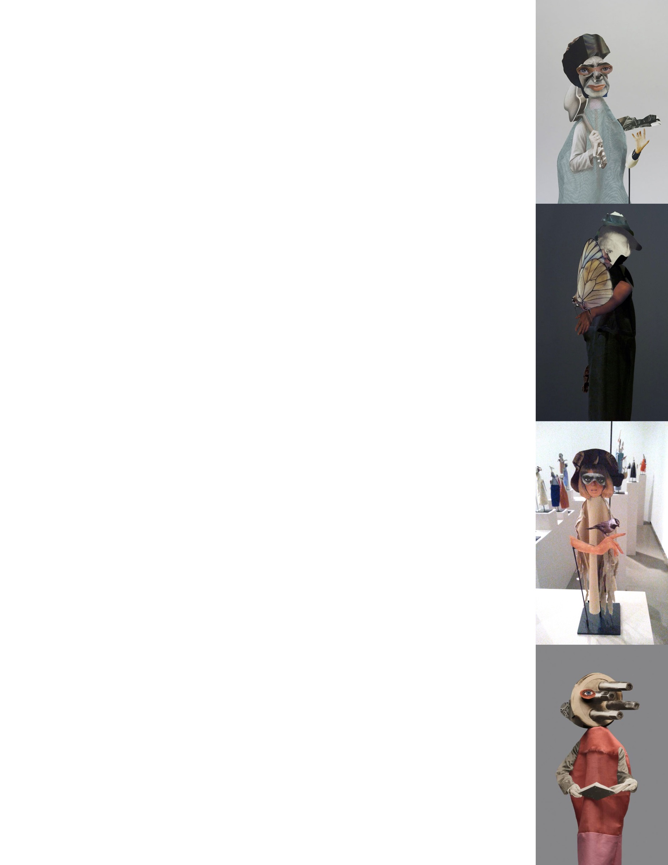


Exploring who we are and how we see our world is what most artists set out to discover. Geoffrey Farmer’s art stems from his search for his place in the world; his whimsical, exciting paper sculptures will serve us as inspiration for this first project. Your goal will be to design and create a three-dimensional paper sculpture that represents your view of the world, your goals, aspirations, how you see yourself and your passions.
Keep in mind that you will express yourself, but not everything has to be made clear to the viewer; symbolism can be a wonderful tool in this project. Your final write-up should explain your choices, but the write-up will be confidential.
What defines you as a person and as an artist? What is your place in the world? What are your passions? How do you view creativity? What is your purpose, and what gifts do you bring to the world?
Media: paper cut-outs (magazines, print-outs, books or hand-drawn); fabric, needle and thread; glue and hot glue; wooden base and sticks; foam board; paint; small found objects such as buttons.
Process:
- In your sketchbook or paper, brainstorm ideas using words and images. Make sure to consider items and themes that reveal something from within. Your creative process for your end product is a large part of your mark.
- After thinking of what represents you, hunt through magazines and find images that match your ideas. They don’t have to be exactly the same, but have the same meaning.
- Roughly cut out the images and place them in an envelope.
- Develop a good sketch of what you think your doll will look like, now that you have found your images. KEEP IN MIND: This is a three-dimensional structure to be seen from at least two views (front and back), so you would have to design accordingly.
- Carefully cut with the thin X-Acto knife each element and place them back in the envelope.
- If something that matters to you is missing, find it on the internet and print it out, or draw it on paper.
- Make the cloth body.
- Paint the wood base black.
- Mount the body and start adding your elements. Remember to reinforce the big ones behind with folded paper skeletons. Some videos can be found at www.themonkeybin.com as well as a slideshow with Geoffrey Farmer’s work.
Write-Up:
Choose a title for your puppet. Write a paragraph explaining your choices and how these choices represent you.
We will have a giant show in November with all the students from grades 9 through 12.



