Out of the Cradle Documentary – Think Sheet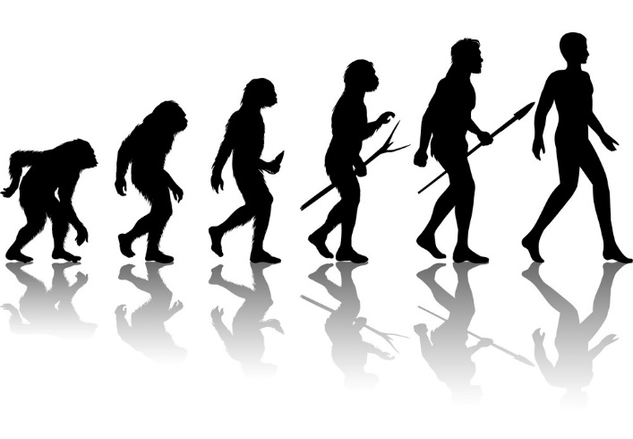
Student: ______________________

1. Ardipithecus ramidus was an important predecessor to Homo sapiens. They could go up on trees, but also walk upright. What was the benefit for this species to be able to walk upright in their environment?

2. How do scientists believe monogamy in our species developed, and why is this a benefit?

3. If a paleontologist studies fossils, what do you think a paleoanthropologist studies?

4. The Homo habilis line survived, even though it was weaker than its competitors. What caused them to win the evolutionary race?

5. Homo erectus, who lived almost 2 million years ago, developed very little body hair. How was the lack of hair an advantage for this primate?

6. Other primates already walked upright; why was Homo erectus different in terms of his posture? What made him a good runner?

7. How did a diet rich in meat affect hominid’s brain development?

8. Homo sapiens hid from their first ice age by moving towards the water. Only a few survived. How did our curiosity help the few survivors hiding near the coast?

9. Despite being stronger and probably just as smart as Homo sapiens, Neanderthals died out. Why do you think this happened?

10. Why did the skin and hair of humans change when they got out of Africa?

11. Homo sapiens somehow developed technology and improved it over time, while the Neanderthals stayed pretty much the same throughout millennia. How did this affect their survival chances? How do you explain this phenomena?

12. How was our brain different from Neanderthals, and why did this give us an advantage?

13. Early Homo sapiens bonded with their community groups in such a strong way that they started viewing other communities as enemies and competitors for resources. How does this relate to our modern world? Can you find a correlation?

14. So far, we have been very good at changing the world to suit our immediate needs. Do you think we have evolved enough to change the world for reasons that may not be immediate, such as our own demise due to climate change? Explain your answer.

