Perspective Zentangle

Have you ever seen a drawing that just doesn’t look right, but you just can’t put your finger on it? Maybe it was a matter of perspective.

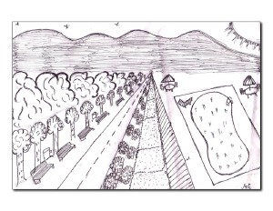

Is the pool flying?

Learning how to draw things in perspective is an important step towards becoming a better artist. This does not mean that you will forever start your paintings with perspective lines; rather, it will keep your mind aware of perspective lines found everywhere. This applies not only to buildings, but to anything that occupies a certain depth.

There are many ways to draw in perspective; we will focus on the three basic ones.

One point perspective:
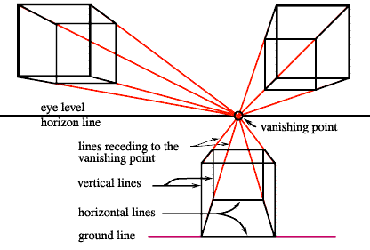

Two Point Perspective:
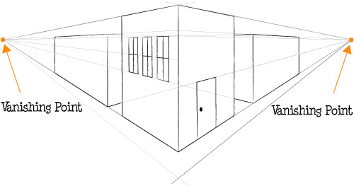

Three Point Perspective:

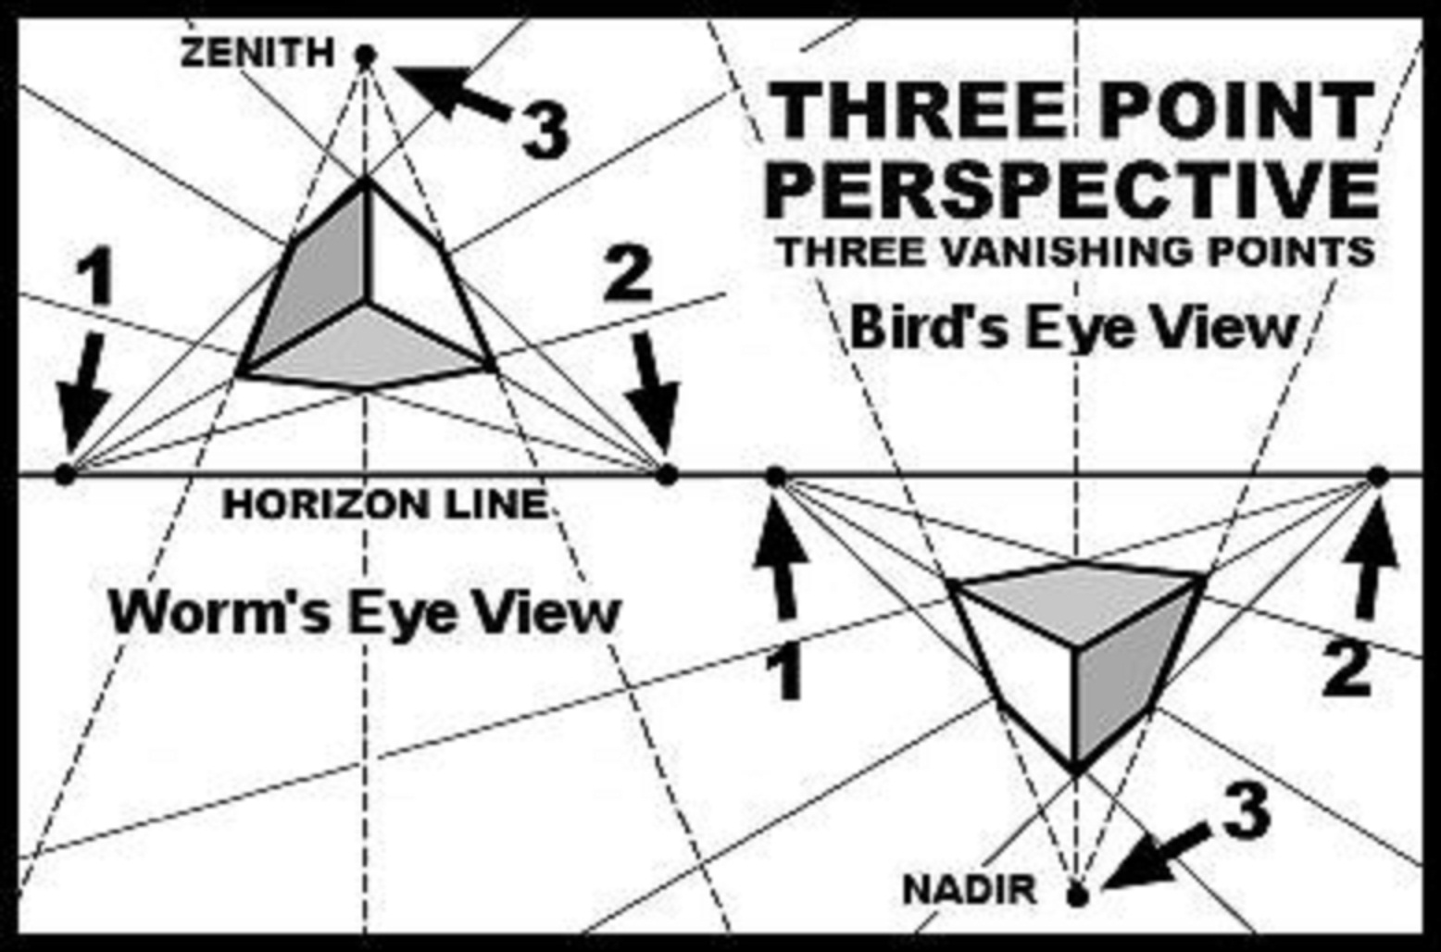
With three-point perspective, you can accomplish very realistic results, such as the one below.

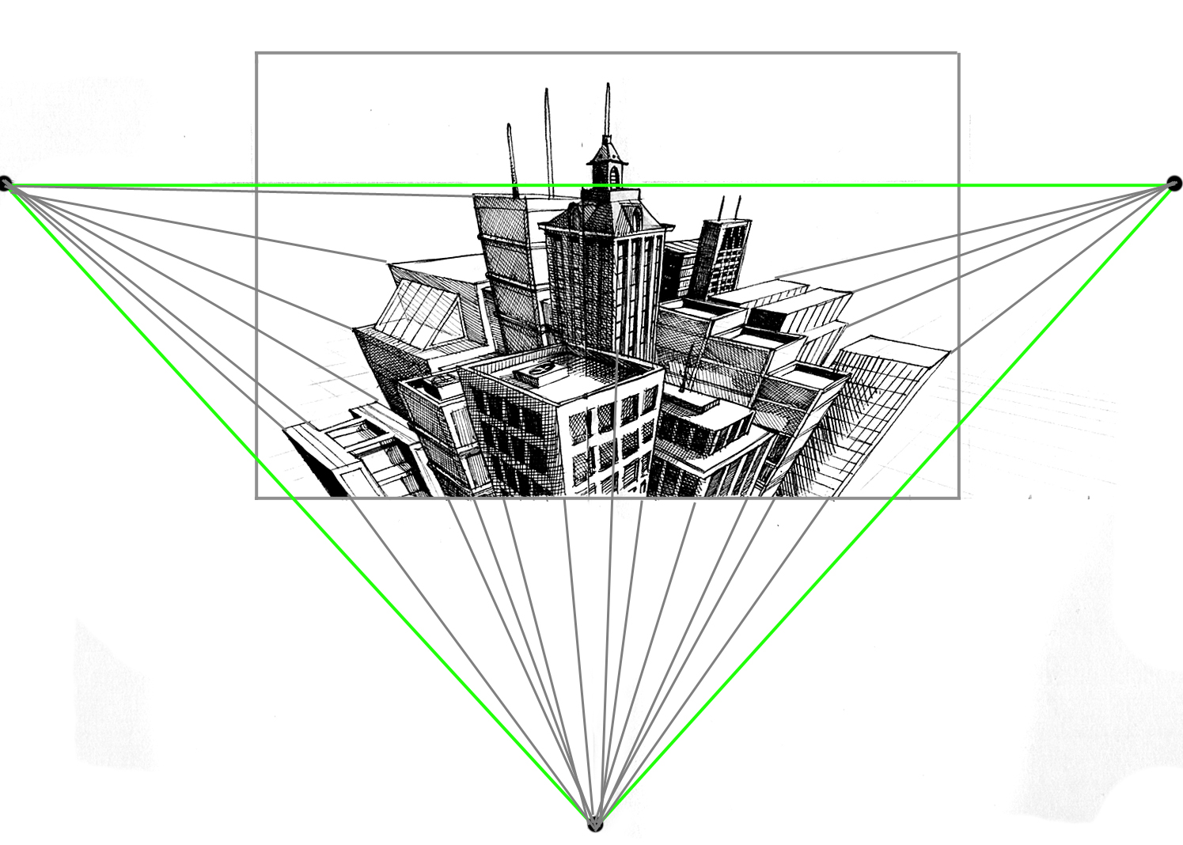

Your task:

- Sketch at least 30 patterns/textures you are interested in
- Select your favourite 20 and prepare your final display piece in pencil
- Cover it with fine liner and sharpie, put your name on it and hand it in
        - Worth 20% of your mark

- Finish a two or three-point perspective drawing with pencil
- Place some detail on it, but not much; think main shapes instead of little flowerpots on the windows.
- Cover your design with your twenty patterns. If you need more patterns, go for it! If you want to leave some spaces blank, go for it! The final design is the most important part.
- Erase pencil marks.
- Worth 80% of your mark

Materials: Scrap paper; nice paper; sharpie; pencil; eraser; fine liner.

SEE RUBRIC FOR MARKING EXPECTATIONS

