Summary – Electricity 1

There are two types of electricity: static electricity and current electricity. In static electricity, an electric charge builds up and then can move rapidly from one location to another in a static discharge. If you have ever walked across a rug on a dry day and felt a small shock when you touched a doorknob, then you have experienced a static discharge.
To understand static electricity, we first must understand the parts of an atom. An atom is made of a nucleus with protons (positive particles) and neutrons (neutral particles), and a cloud of very energetic electrons (which are negative) spinning around this nucleus. A balanced atom has the same number of electrons and protons.
This cloud of electrons are organized in orbits, just like our planets spinning around the Sun; except the electron moves so fast, it forms a cloud of probability. That means you can never be sure where the electron actually is!

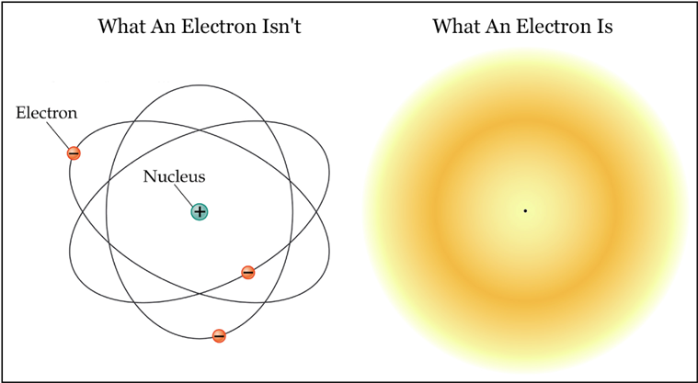
The electrons are not only high on energy, they are also far away from the nucleus; inner electrons don’t leave the atom, but the outer layers of each atom have electrons which separate easily.
With friction – such as when you walk around on a carpet – some of those electrons leave your body, making you more positively charged. This is called a charge imbalance. The thing is, an atom’s nature is to search for balance. When you touch a surface that has extra electrons then the electrons will jump to you, bringing equilibrium. This discharge is felt as an electric shock.
This doesn’t happen to everything in the world, otherwise we would get shocked every time we eat an apple, for instance. Some materials are called conductors, and they have loosely bound electrons on the outer layers. Metals and salt water are conductors, for instance. Insulators, however, such as rubber, plastic and glass, have very tightly bound external layers, so they won’t lose electrons.
People who work with electricity often buy special rubber boots that insulate them from any electric discharge, so even if they touch something with high voltage, they will be protected because the electrons won’t be able to flow through them towards the Earth.
A more spectacular form of static electricity is lightning. It's like a giant rug and doorknob effect!
Current electricity is quite different. This is electricity that has been controlled or trained by human means.
In this case, the electric charge moves through a wire or another material that conducts electricity. This material is called a conductor.
When you turn on the lights or the TV, you use current electricity. When you use a battery-operated gadget, you also use current electricity that comes from the battery rather than from the wall socket.
The way a battery works is simple. It creates a negative side by forcing a metal (Zinc, for instance) to lose its electrons via oxidation. These electrons are attracted to the other end of the battery as they try to balance a substance which is rich in positively charged atoms, in a process known as reduction. When the substance is all used up, the battery is done, and you need to get a new one.
A charged atom is called an Ion. Ions can be positive or negative.
On our experiments, we created circuits with batteries and watched them turn on lights as well as disturb the orientation of the compass.
However, how does a circuit work, exactly?
An electric circuit is a continuous path for electricity to flow through. The electricity in this type of circuit flows in one direction (known as direct current, or DC) in a continuous loop from the negative terminal to the positive terminal of the battery.
Electrical current is simply the movement of electrons in a conductor. The energy from the battery provides the power (voltage) to cause the electrons to flow from one end of the dry cell (the power source) to the other.
Did you know? Batteries are referred to as dry cells because the energy source inside the battery is in a paste.
Basic components of a simple circuit:
- Load - the part of the circuit that uses the electricity. In our experiments, the load was the light bulb. Other examples include a toaster, a fan or the dishwasher.
- Power source - where the energy comes from. We used batteries for our experiment.
- Conducting material - often copper wire that connects the battery to the load and back again to the battery. For electricity to flow around a circuit, the circuit needs to be complete (or closed) without any breaks in it.
Magnetism
Magnets are commonly made of iron, or sometimes a mixture of other metals. Cobalt and nickel are also magnetic, but iron is the most commonly used metal for magnets.
If you could draw a magnetic field on a bar magnet, you would see lines moving out from the North pole, curving around and returning to the South pole, just like our experiment with the iron filings.
The magnetic field is strongest inside the magnetic material. Around the magnet, the strongest fields are around the poles. As you get further and further away from the magnet, the power diminishes until it is no longer perceptible.
Have you ever heard that opposites attract? This concept came from magnets. While it is not true for human beings, it does work for magnetic attraction laws. A magnetic North pole will attract the South pole of another magnet and repel a North pole.
The Earth also has a magnetic field with two poles. The reason for this is, the Earth has a solid inner core, two thirds of the size of the moon, composed mainly of iron! At 5,700 degrees Celsius, this core ball of iron is as hot as the surface of the Sun. However, due to the pressure caused by gravity, it does not become liquid.
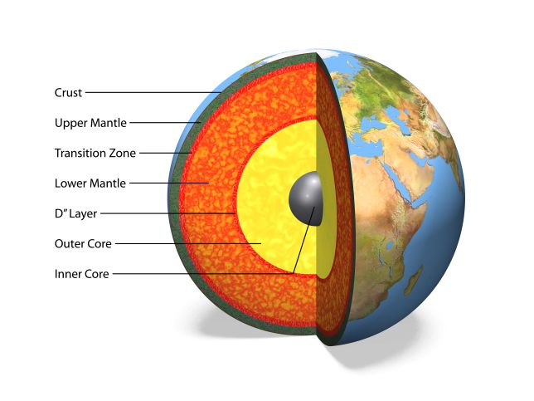
Surrounding this inner core, there is a 2,000 Km thick layer of iron, nickel and other metals. There is less pressure here than in the core, so that means this layer is fluid. The flow of this liquid generates electric currents, which in turn produces magnetic fields.
What are these good for, you may ask? Many things, actually!

Besides helping us navigate and find our way around the world, the Earth’s magnetic field also protects us from the Sun.
The Sun produces a stream of energized particles, called solar wind, which bathes the Earth all the time. Thankfully, the Earth's magnetic field extends far out into space and shields our atmosphere from the solar wind. The interactions between Earth's magnetic field and charged particles coming from the Sun are often referred to as "space weather" and cause phenomena such as the aurora borealis or Northern Lights. It also causes satellite failures and radio transmission problems.
The needle of a compass is really a tiny magnet with a pointer. It is suspended in liquid, just like the Earth's core. It is affected by the Earth's magnetic field and aligns with it (North to South). The red side of the needle always points to the Earth's magnetic North pole. The first navigation compasses were just pieces of lodestone tied to a piece of wood, floating in the water. The lodestone would align with the Earth's magnetic field.
You can think of the Earth as having a giant bar magnet buried deep within. When we put a magnet near the compass, it overrides the Earth's pull because the magnet has a stronger magnetic field than the Earth's core, so the compass needle aligns with the magnet.
So, we saw that magnetism is related to the Earth and involves attraction and repulsion of materials. But we also saw through our experiments that magnetism is related to electricity. When a circuit is closed, the electrons in the wire move through the closed loop; this movement creates an electrical current.
The movement of electrons through the metal produces a magnetic field around the wire similar to how the Earth's magnetic field is created by the movement of liquid metal.
If you place a compass near a wire carrying an electrical current, the needle will move, possibly aligning it with the magnetic field lines!

--------------------------------- End of Summary 1 ----------------------------------

