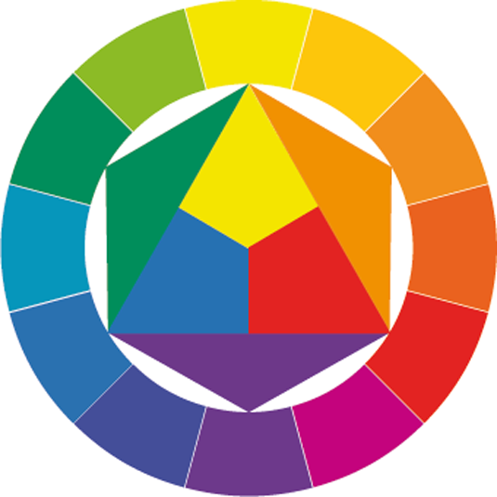
What is an Immigrant?
An exploration on colour

Canada is a country built by immigrants. Most of us have come from a family that has just moved to Canada in recent years; many of us are, ourselves, immigrants, leaving our country of birth to find a new life in a foreign land. But when all of us are here together, many questions start to appear; your task is to choose one of these questions and explore it visually, in order to portray a message.

Some questions that come to mind:

- How are recent immigrants seen by the white majority?
- If you decide to leave Canada and go to school offshore, what does this make you?
- Have you seen animosity against a specific type of immigrant?
- How does it feel to be in a new country, and call it your home?
- Is it fair for some people to get a shot at a new life, while others get shot trying to escape their countries?
- What are borders?

And many, many more. You decide!

Your task:

- Pick your question. This will be the title of your piece.
- Sketch three ideas for a new painting. Pick one to paint.
- Paint a colour wheel (modern, traditional or masters)
- Paint the gradients of each colour.
- On a canvas, paint your final image using a restricted colour pallete.

Materials:

- Acrylic on Canvas

Deliverables:

- Three Sketches (10%)
- Colour wheel and Gradients (10%)
- Final Painting (80%)

